Restaurant Project Mission Statement

INTRODUCTION:-

Nowadays all the organizations in all the word, goes to use the technology in their daily processes, in order to manage and simply maintain their works and process, this make the organization more dynamic and has the ability to response to the change.

Because of the network, and its ability to connect people together, and it's application such as internet, this make it easier to deal with different transactions remotely and dynamically such as, EBanking, ECommerce, EShopping that is used over the existence of the internet.

ABOUT THE SYSTEM:-

The system is Al Aqsa restaurant, that provide it's services all day time, has a daily works to make it's best in order to meet the customers needs ,has a manager who is responsible for managing the restaurants, the manager also has a lot of privileged access to every thing in the restaurants processes or operations. A set of employees ,where they are responsible for the process of providing customers by what they are need or request when they need it ,they prepare the food, sweets and the drinks; that is requested by the customers .A set of customers, they represent the basic block of the project.

The system has a repository, where the foods, drinks and sweets are stored. This repository needs to be managed, either manually by the manager, or automatically, through the system web site. Managing process has to record every transaction out from the repository, and every transaction entered the repository, which required a Reporting system to manage the process.

The system can accept a limited number of customers at the same time; this is because the number of tables in the system is limited, the system have to manage the reservation process , and determine their times, for the customers, in order to try to serve the customers in the best possible way. The system will serve the customer according to their access or reservation time, the customer who come and/or reserve first, serve first, which means there is no need for the intermediate man, who some times serve the one he want, when he want.

The system has an Reporting system, that is responsible for managing all the transaction within the restaurant, it record all incoming, and out coming transactions ,in the sales process , and the buying process, makes discounts for the customers that are special members or well known customers, making a pill for the customer; when the customer select what they need. The Reporting system makes it easier for manager, employees and customers to know what is the cost of every operation, and the date or the time of these transactions.

Every one deal with the system directly or indirectly, must provide the system with a lot of information, where this information is necessary for the process of managing the system. Customers, when deals with the system, must provide the system with some information.

If the customer visit the system for the first time; in this case, customers have to provide the system with a set of information, to be saved in the system database. This information include:-

- Customer ID .
- Customer Name.
- Customer Address.
- Customer Phone.
- Customer Age.
- Customer Sex.

After the first visit, the customer become as a member, and to gain access to the system, in order to reserve a table in the system; in this case, he can provide his ID and Password to complete the reservation process.

An Invoice will be computed for the customer; when he reserves a table or delivery man, this Invoice will contain the following information:-

- The Name of the Restaurant.
- Customer ID and its Name.
- Reservation Date and it's Time.
- Customer Arrival Date and Time.
- Selecting Foods and the price of each one.
- Selecting Sweets and the price of each one.
- Selecting Drinks and the price of each one.
- Selecting Food total price.
- Selecting Sweets total price.
- Selecting Drinks total price.
- Invoice Total Price.
- Customer Discount Amount.

Manager, who is responsible for the restaurant management process, if he see that, the management process, requires more employees; in this case, he can accept or deploy the number of employees, he sees to optimal the process.

When the employee accepted by the manager, the manager register the employee, after taking the necessary information form him. This information include:-

- Employee ID.
- Employee NAME.
- Employee ADDRESS.
- Employee PHONE.
- Employee AGE.
- Employee SALARY.
- Employee SEX.
- Employee IMAGE - if necessary- .

The system has different integrated parts, which are necessary for managing the system, these parts are integrated in a single department, which is called the Repository:-

- Foods department.
- Sweets department.
- Drinks department.

The repository in integrated with the suppliers, so, when the repository capacity decreased to a danger line (The Red Line), the system dynamically update the repository, when the amount of each type become less than or equal to 20 unit. Manager can also update the repository, according to a specific amount of every part manually.

Repository system is also integrated with the Reporting system; which is one of the most important departments in the system. The Reporting system records every operation or transaction from or to the repository.

The system has two type of communication between customers and manager either by internal messaging or sending messages to manager email.

System organizational view

Employee

Manager

Customer

Restaurant

Reporting
ٍSystem

Repository
ٍSystem

About the Reporting System:-

The Reporting system-which can also represented as an Accounting System- specify the type of the transaction within the repository system, where the transactions could by buying or selling process. For the buying process _ which is cause increase the repository, the management process requires to register any transaction information. Buying transactions requires the following information:-
- An ID given to specify the process.
- Buying NAME.
- Buying TYPE (FOODS, SWEETS, and DRINKS).
- Buying DATE.
- Buying AMOUNT OF EACH TYPE.
- Buying TOTAL PRICE.
- Buying Action (Admin or System).

The Reporting system also manages selling process, since the management process requires registering any transaction information. Selling transactions requires the following information:-
- An ID given to specify the process.
- Selling DATE.
- Selling TYPE (FOODS, SWEETS, and DRINKS).
- Selling AMOUNT OF EACH TYPE.
- Selling TOTAL PRICE.

The Reporting system has responsibility for preparing customers pill, after the reservation process is complete, and the customer choose all what he need, the Reporting system send to the customer a message contains every thing he choose, with the price of each type, if the customer ensure or accept the message , the Reporting system reserve a table to the customer, according to what the customer need, and according to the customers arrival time to the restaurant, the Reporting system send a message to the employees, in order to start preparation of every thing the customer choose, to be available, when the customers arrive.

Relational Data Base
(Actual System Data)

Administrator:
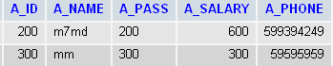
Figure 1:Administrator Relational DB

Buying:
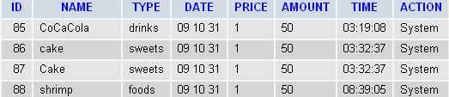
Figure 2: Buying Relational DB

Customers:
Figure 3: Customers Relational DB

Drinks:
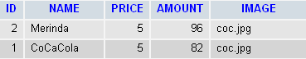
Figure 4: Drinks Relational DB.

Sweets:
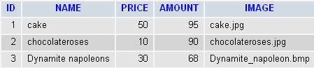
Figure 5: Sweets Relational DB

Foods:
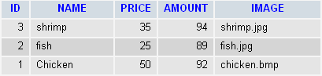
Figure 6:Foods Relational DB

Employees:
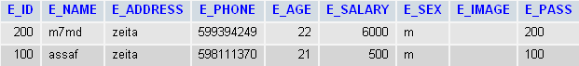
Figure 7:Employees Relational DB

Invoice/ Pill:
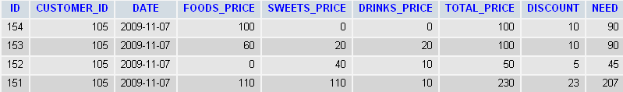
Figure 8:Invoice Relational DB

Invoice/ Pill:
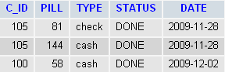
Figure 9:Invoice Relational DB

Reservations:
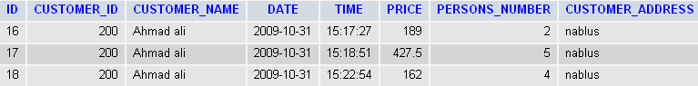
Figure 10:Reservations Relational DB

Tables:
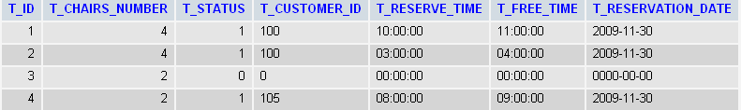
Figure 11:Tables Relational DB

Delivery_men:
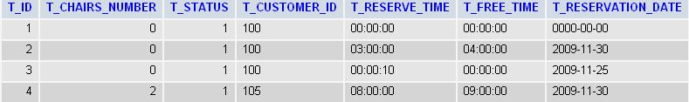
Figure 12: Delivery_men Relational DB

Messages:
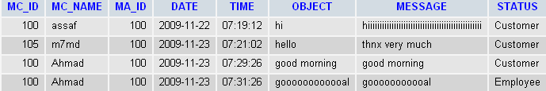
Figure 13: Messages Relational DB

Votes:
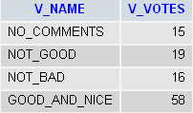
Figure 14:Votes Relational DB

Data Base Schema:
Administrator( A_ID :int(12), A_NAME:varchar(21), A_PASS: varchar(21),A_SALARY:float,A_PHONE:int(12))
Customers(C_ID:int(12), C_NAME:varchar(21),C_ADDRESS: varchar(21),C_PHONE:int(12),C_AGE:int(12),C_SEX:varchar(21),C_STATUS:varchar(21),C_VISIT_NO:int(12),C_VISIT_DATE:date,C_PASS :varchar(21) )
Employees(E_ID:int(12), E_NAME:varchar(21),E_ADDRESS: varchar(21),E_PHONE:int(12),E_AGE:int(12),E_SEX:varchar(21),E_SALARY:varchar(21),E_IMAGE: varchar(21),E_PASS:varchar(21) )

User Interface Sketches
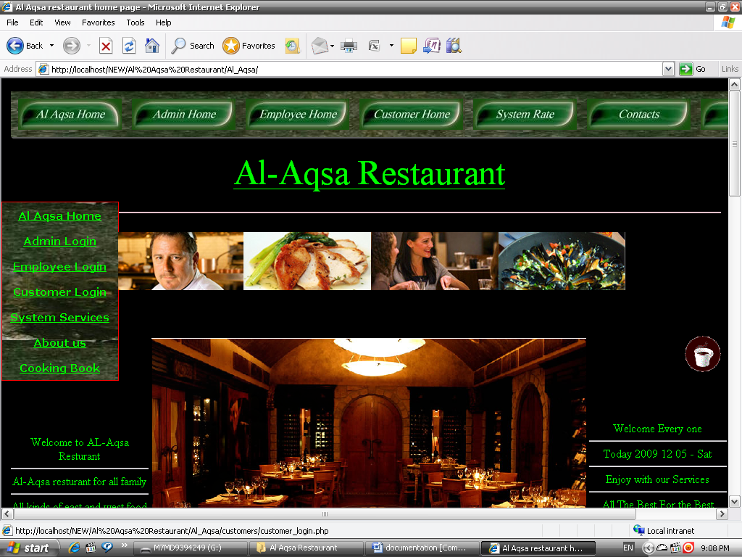
Figure 15: Al Aqsa Restaurant index

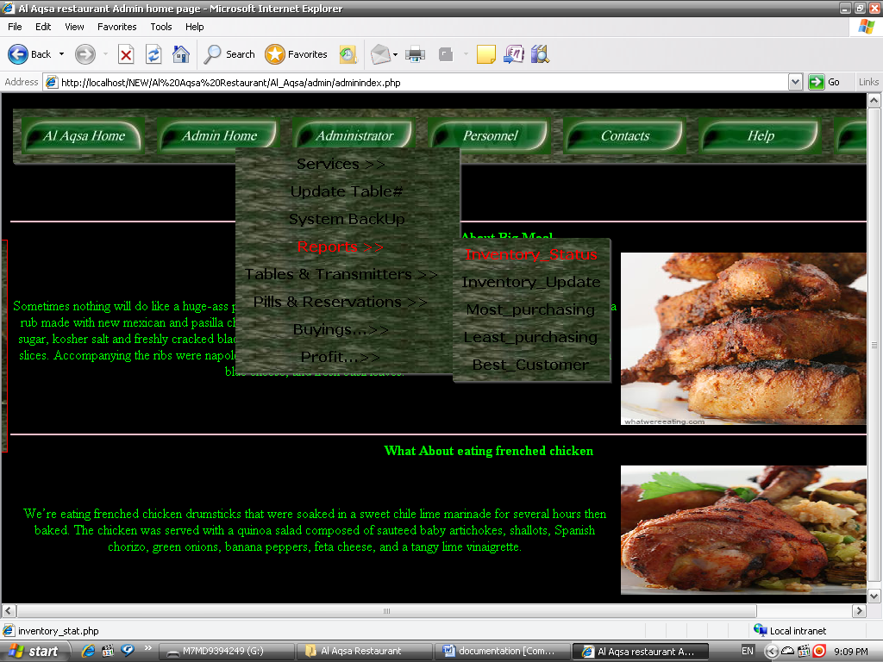
Figure 16: Admin Home Page

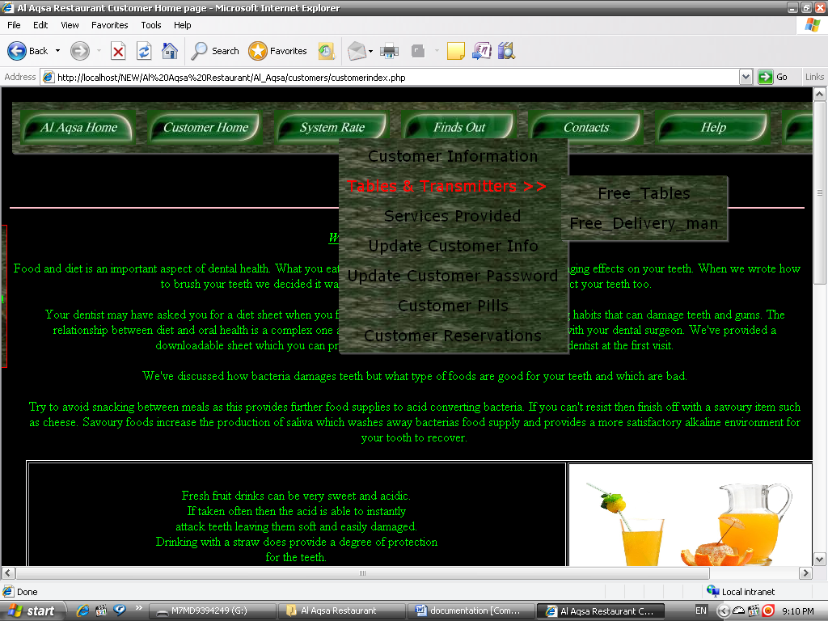
Figure 17: Customer Home Page

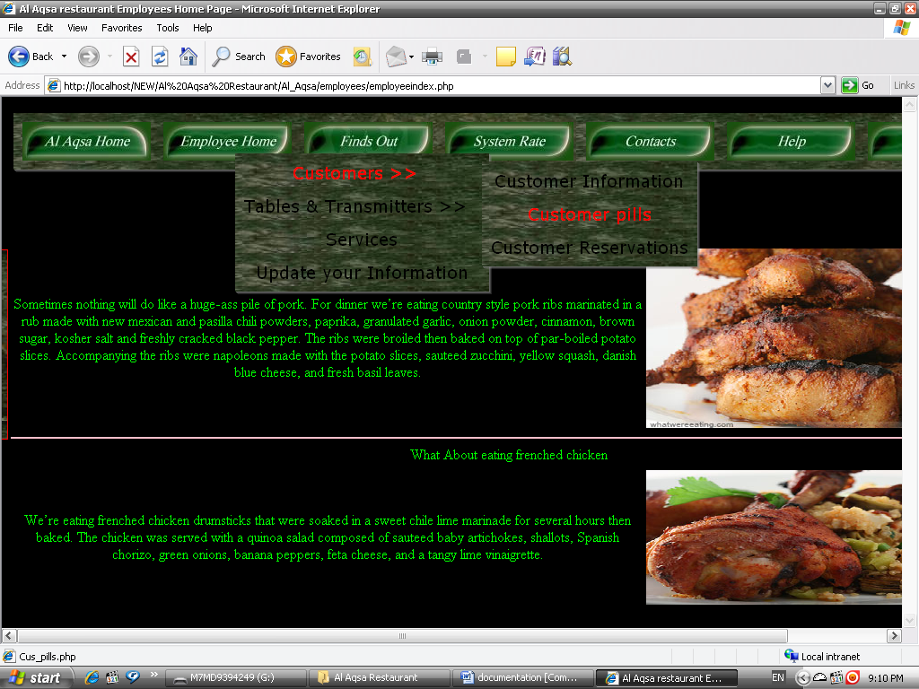
Figure 18: Employee Home Page.

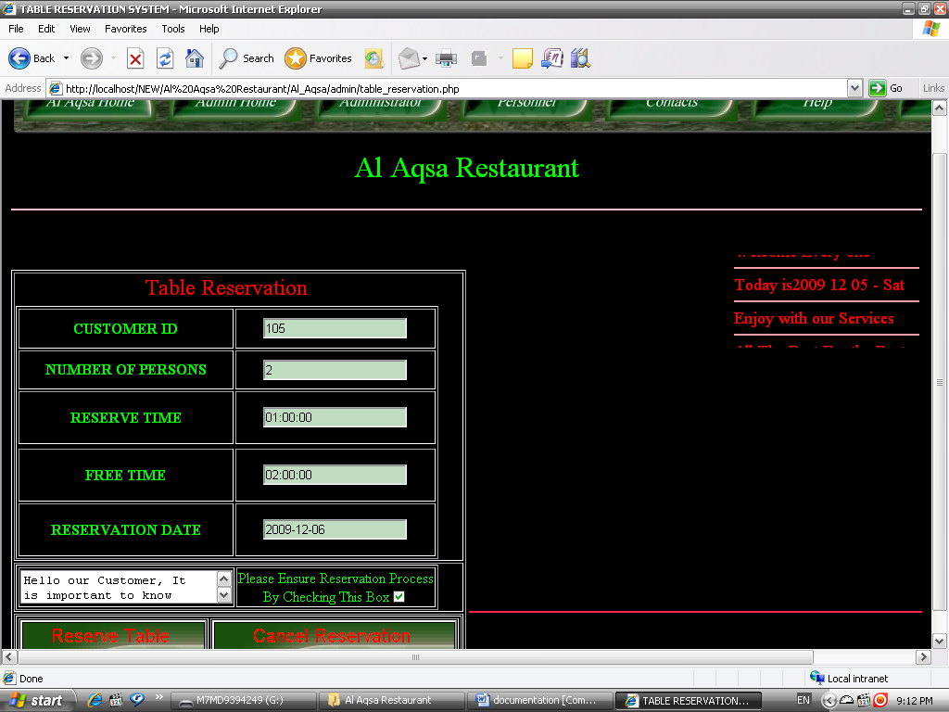
Figure 19: Reservation Process.

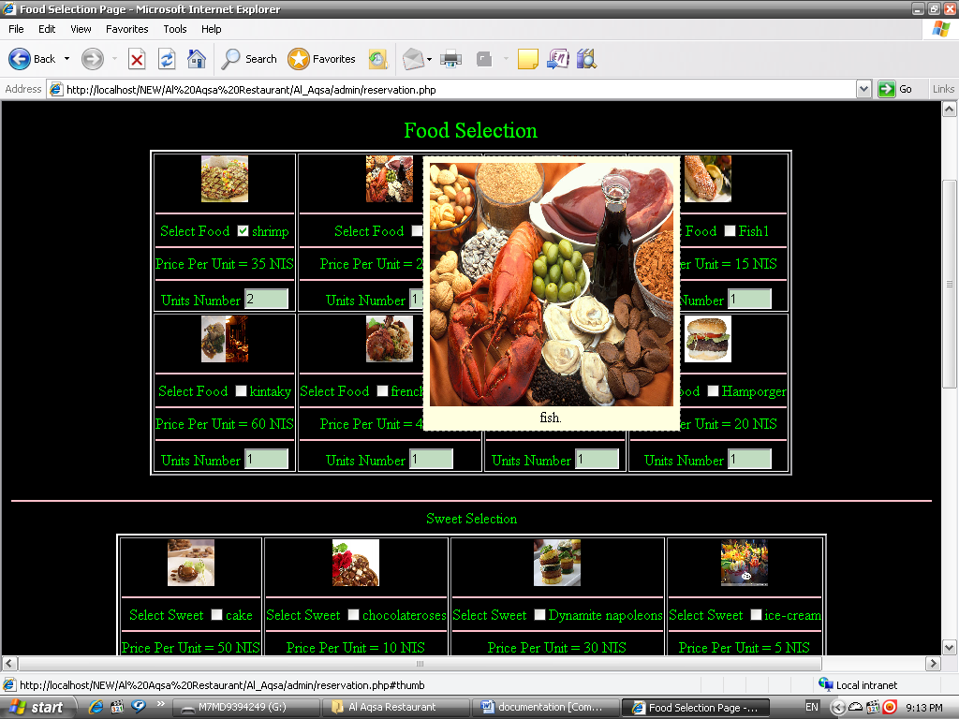
Figure 20: Selection Process.

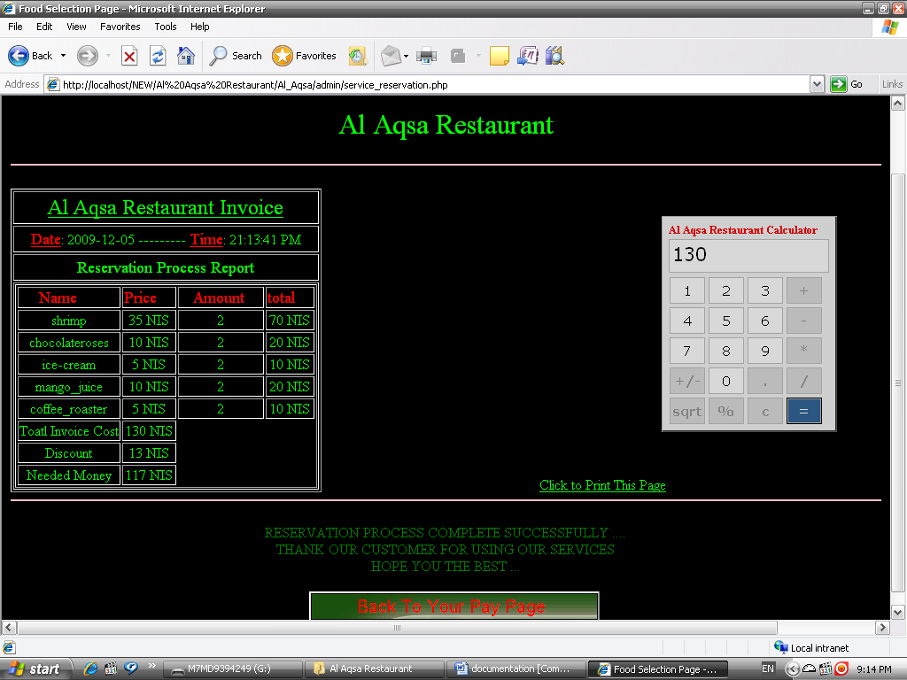
Figure 21: Reservation Process with Invoice.

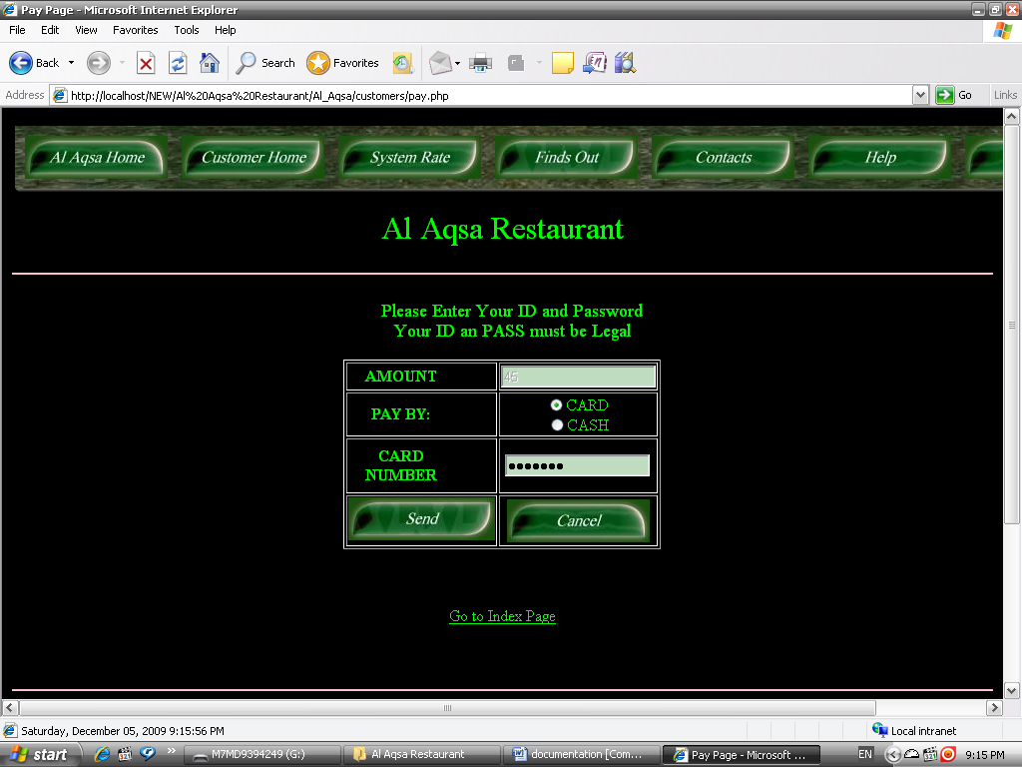
Figure 22: Paying Page

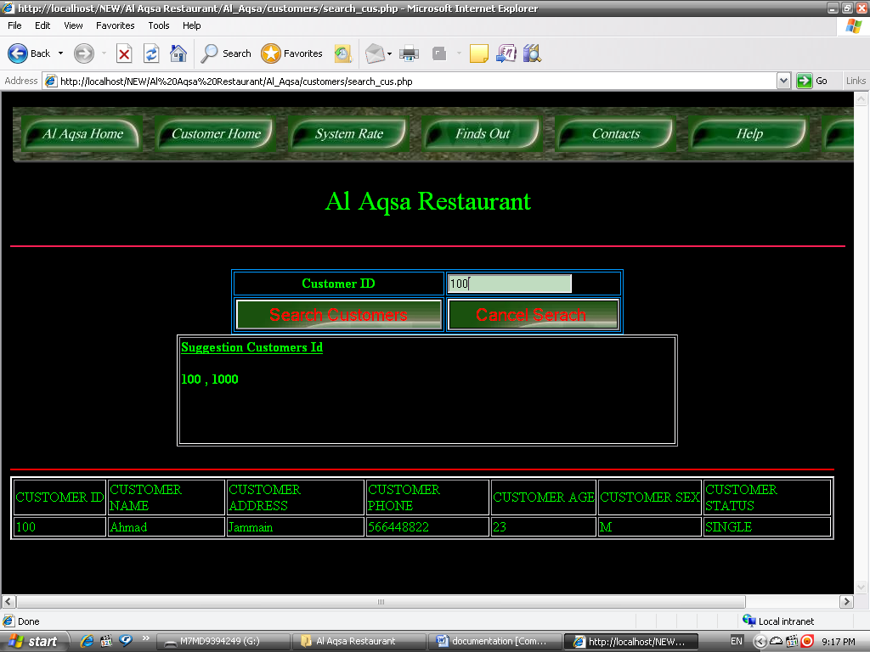
Figure 23: Searching Customer Information.

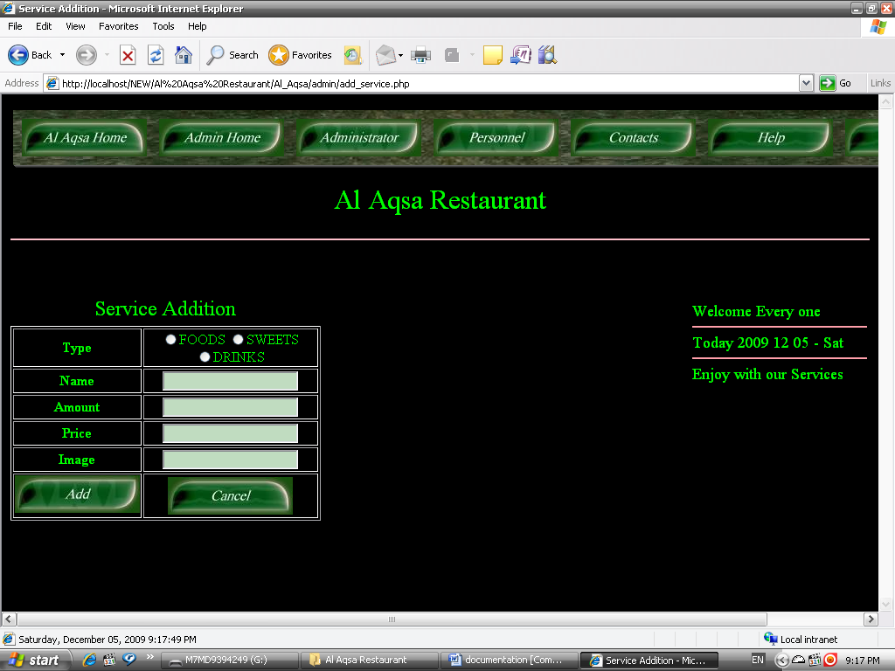
Figure 24: Service Addition.

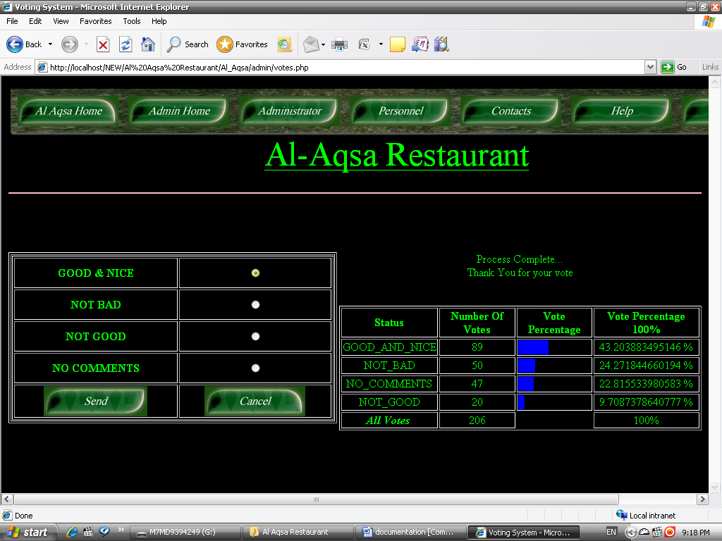
Figure 25: Rating the System.

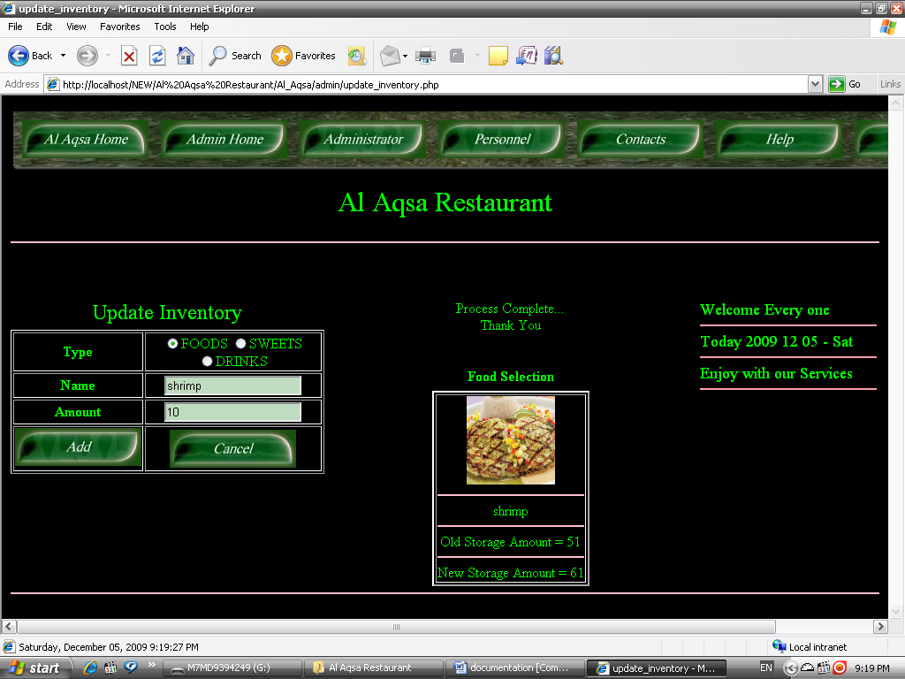
Figure 26: Inventory Updating By Administrator.

Thank You for visiting us, we hope you enjoy your visit
Al-Aqsa Restaurant

